Ideation Phase
Define the Problem Statements

Date
Team ID | 9100FusionForce
Project Name | Script-Controlled ACL
Maximum Marks | 2 Marks

Customer Problem Statement Template:
Create a problem statement to understand your customer's point of view. The Customer Problem Statement template helps you focus on what matters to create experiences people will love.
A well-articulated customer problem statement allows you and your team to find the ideal solution for the challenges your customers face. Throughout the process, you’ll also be able to empathize with your customers, which helps you better understand how they perceive your product or service.
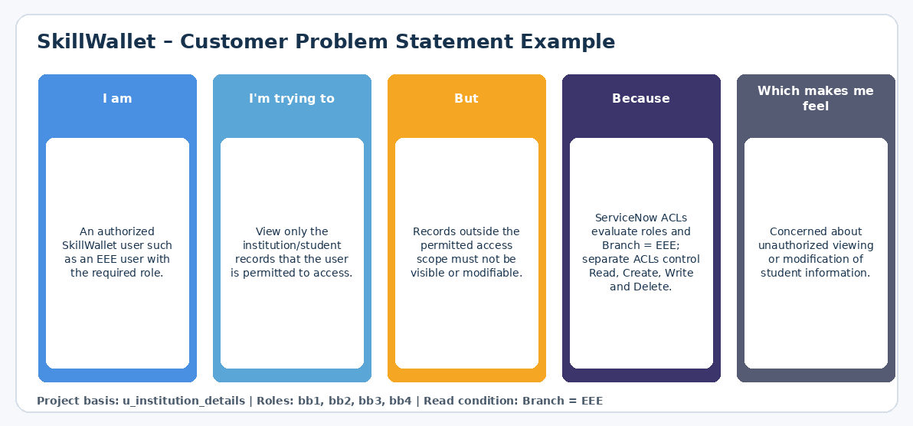

Problem Statement (PS) | I am (Customer) | I’m trying to | But | Because | Which makes me feel
PS-1 | I am an authorized SkillWallet user, such as an EEE user with the required role. | I’m trying to view only the student/institution records I am permitted to access. | But unauthorized records should not be visible to me. | Because ServiceNow must restrict record access using user roles and the Branch field condition. | Which makes me feel concerned about unauthorized access to student information.
PS-2 | I am a SkillWallet user who has permission to perform specific record operations. | I’m trying to create, update, or delete institution records according to my assigned access level. | But each operation requires a different level of permission. | Because Read, Create, Write, and Delete access must be controlled separately using ServiceNow ACLs and roles. | Which makes me feel concerned about incorrect permissions allowing unwanted changes.

